General ethos:

The main idea of our website is to make the website simple and easy to read, but not missing content. We want to be as clear as possible about what the site offers and to let users find what they want to know as quickly as possible.

Site Map:

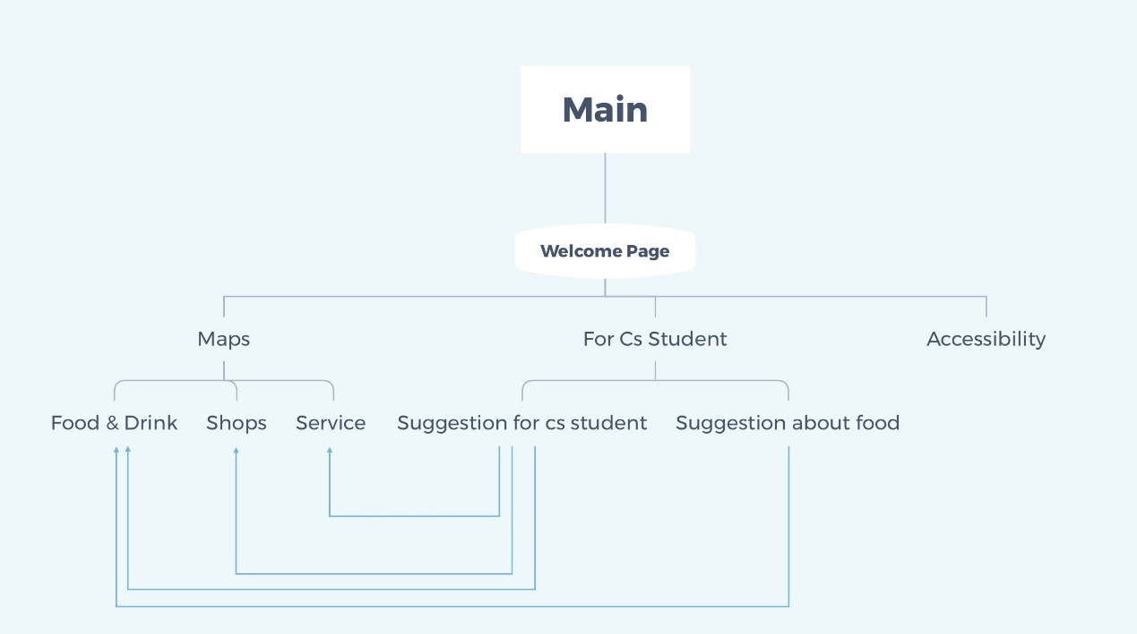

In our structural plan, we feel that it is necessary to make the structure simple to improve the logic of our website. Only our logic is simple enough for users to use more convenient. So, we divided the requested websites into three categories Maps, For Cs Student, Accessibility. The **Maps** section includes **Food & Drink** (the eat things in student union), **Shops** (the shops in student union), and **Service** (the service facilities in student union). The **For Cs Student** section includes **Suggestion for cs student** (give the Computer Science students may experience using the building)and **Suggestion about food** (focus on the eating suggestion)**.**

Accessibility:

After we discussed it, we decided to use the accessibility of the computer system and adapt it to the accessibility part. Because we found that the computer system's own accessibility tools solve problems well and at the same time make the user's experience better, so we made this decision.

Legal issues:

On legal issues, we decided to use our original content as much as possible, and then when we introduced the big category of Maps, we should use the content of some student union websites, and then use Harvard referencing style to quote.

Design mock-ups:

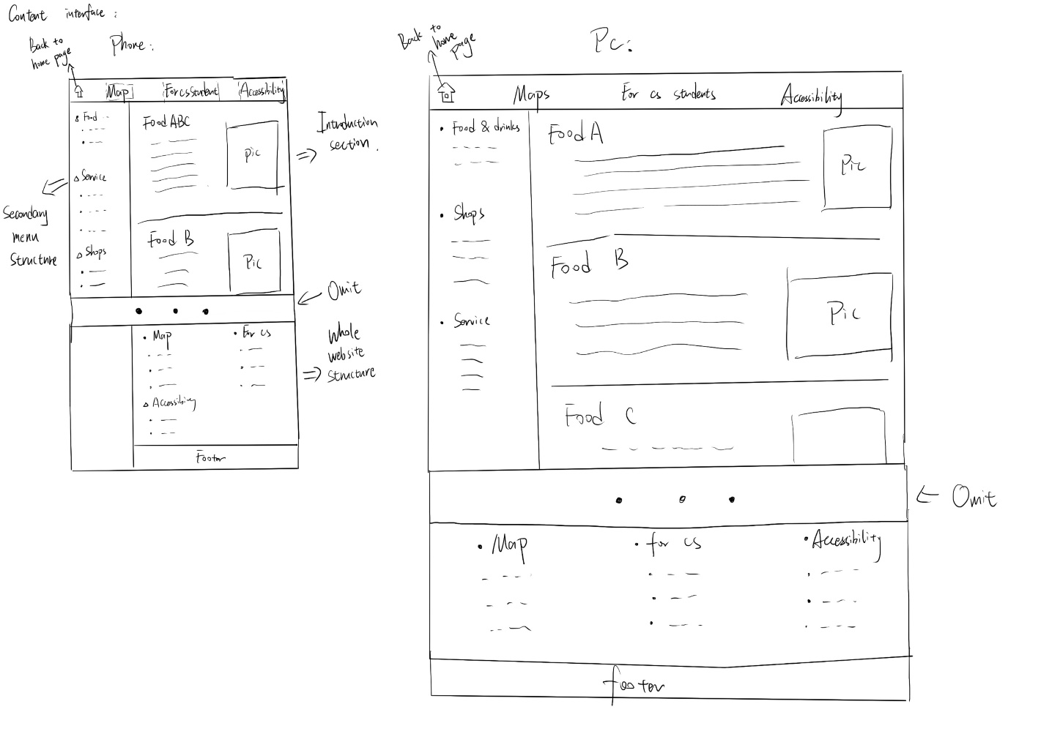

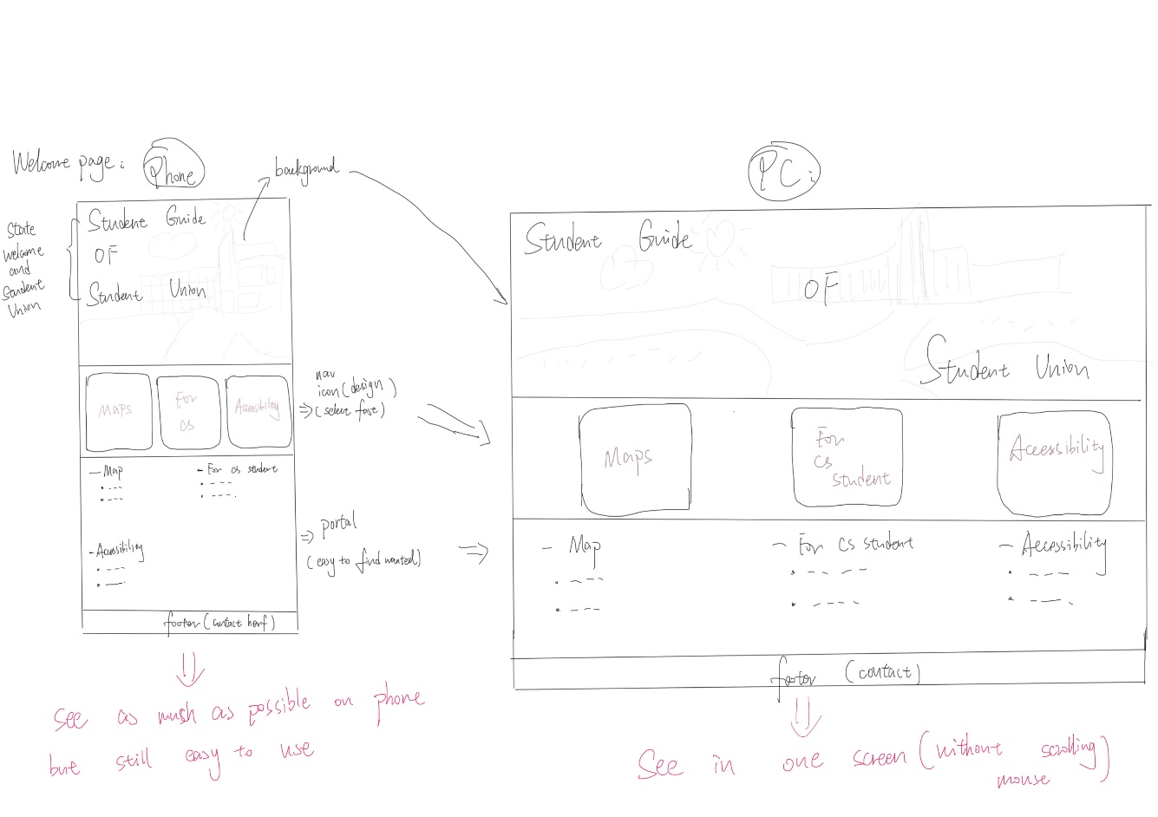

Menu System:

We decided to use the two-tier menu after the discussion. The first level of the menu is about the entire site, so that users can quickly choose across the district, so the design is at the bottom of the page. The second level menu is used to guide the structure of the second layer website, which is convenient for users to find the content of the child website, so it is designed at the left end of the webpage to prevent user logic confusion.